NSSM

Run
nssm.exe install lattice

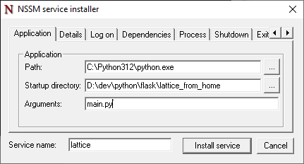

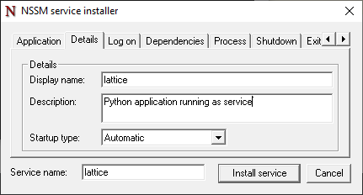

Kill & Remove
nssm.exe stop lattice
nssm.exe remove lattice confirm

Other commands
- nssm.exe status lattice
- nssm.exe start lattice
- nssm.exe stop lattice
- See it at services.msc
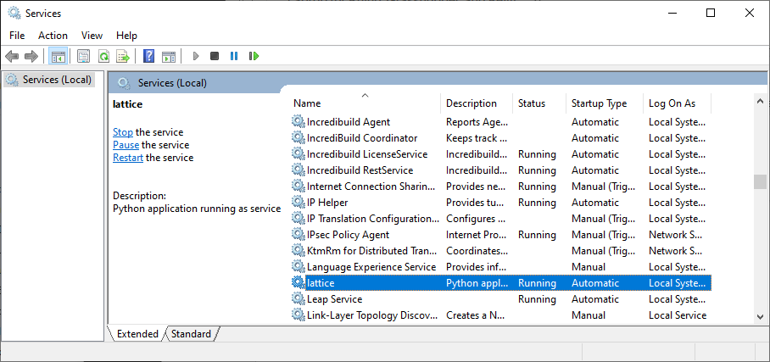

Download
https://nssm.cc/release/nssm-2.24.zip

Rub as batch file
cd C:\nssm\win64

:: Install the service
nssm.exe install MyPythonService "C:\Python311\python.exe" "C:\MyApp\app.py"

:: Set the working directory
nssm.exe set MyPythonService AppDirectory "C:\MyApp"

:: Set to start automatically
nssm.exe set MyPythonService Start SERVICE_AUTO_START

:: Set description
nssm.exe set MyPythonService Description "My Python application running as a service"

:: Configure output logging (optional but recommended)
nssm.exe set MyPythonService AppStdout "C:\MyApp\logs\service_output.log"
nssm.exe set MyPythonService AppStderr "C:\MyApp\logs\service_error.log"

:: Rotate logs to prevent them from getting too large
nssm.exe set MyPythonService AppStdoutCreationDisposition 4
nssm.exe set MyPythonService AppStderrCreationDisposition 4

